TheGenie.ai - GetGeoSocial Area Analysis

For: Angel Flores: Date: June 29, 2024
Company: Shoppingsdhouses
Researched zips: 92119 & 92120 | Known as the Del Cerro & San Carlos Areas
By: Steve H

Del Cerro | Filtered Area
Targeted SFR Homes: 1318

Filters: Est Owners: 2142 (GeoSocial Audience)
- 4+ Bedroom
- 4+ Years in home
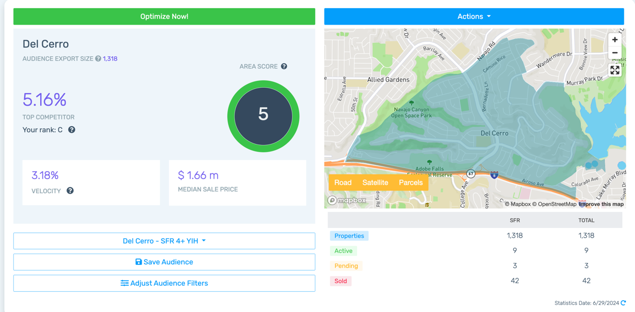
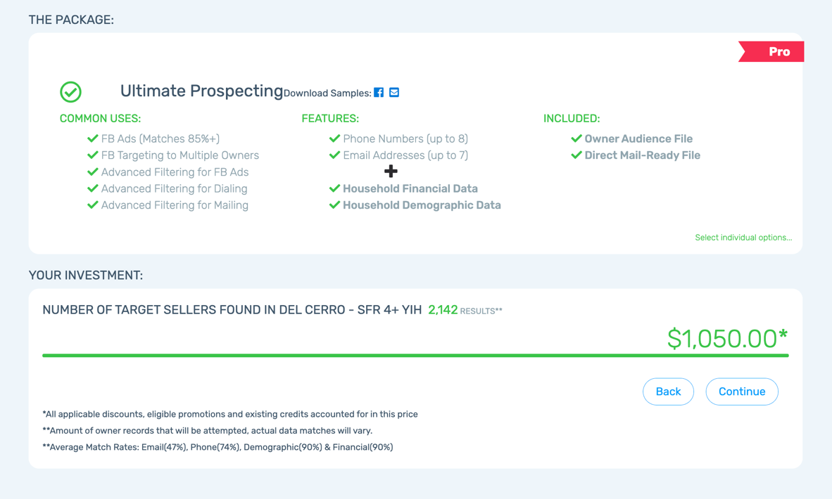
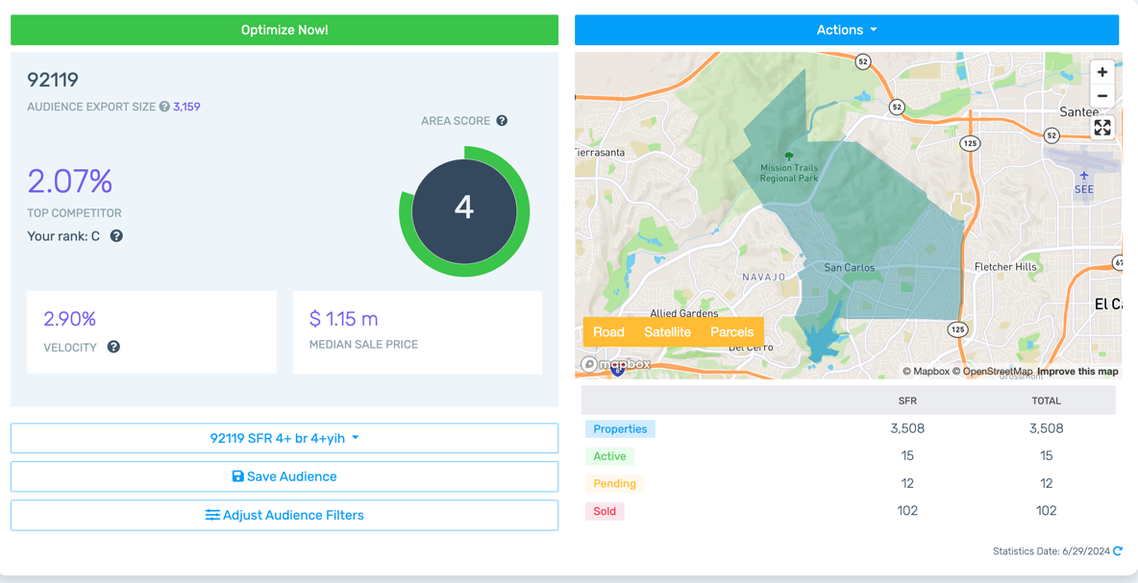
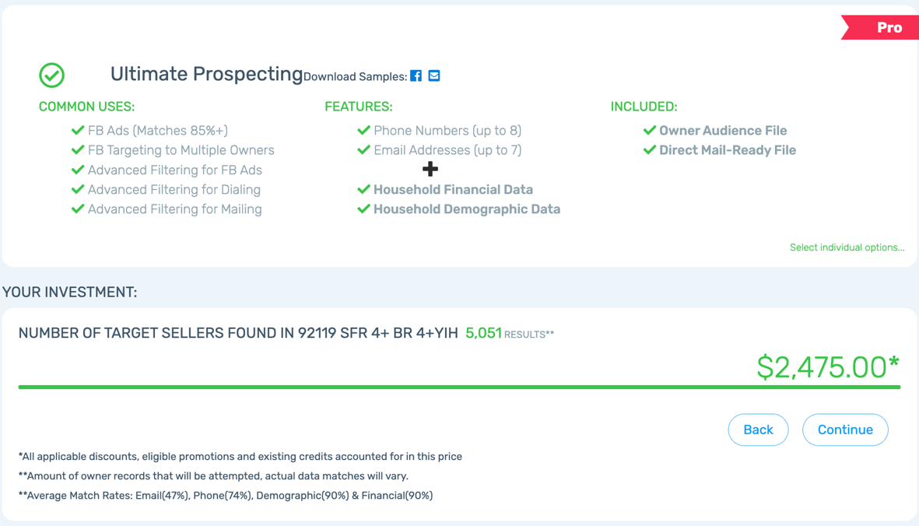
92119 | Filtered Zip Code
Post Filter SFR Homes: 3159

Filters: Est Owners: 5051 (GeoSocial Audience)
- 4+ Bedroom
- 4+ Years in home

The Knolls of Del Cerro
SFR Homes: 226

Filters: Est Owners: 351 (GeoSocial Audience)
- None

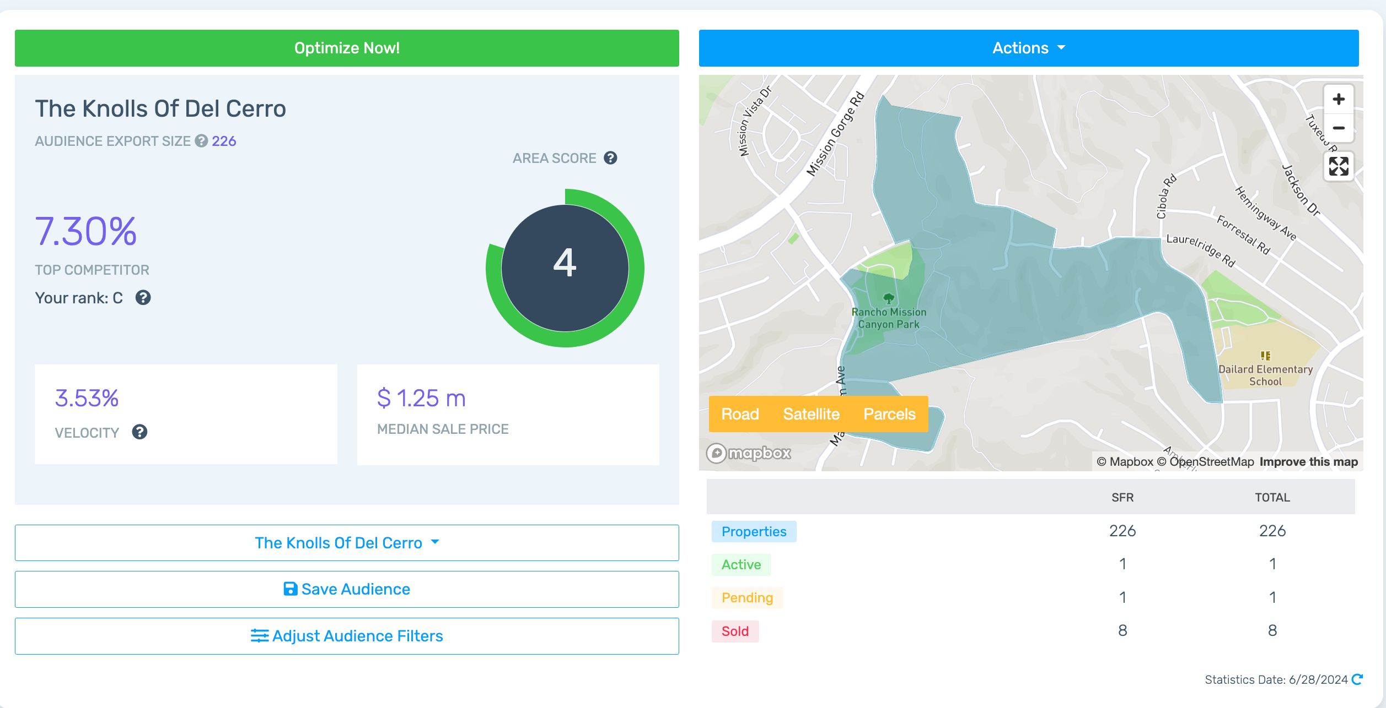
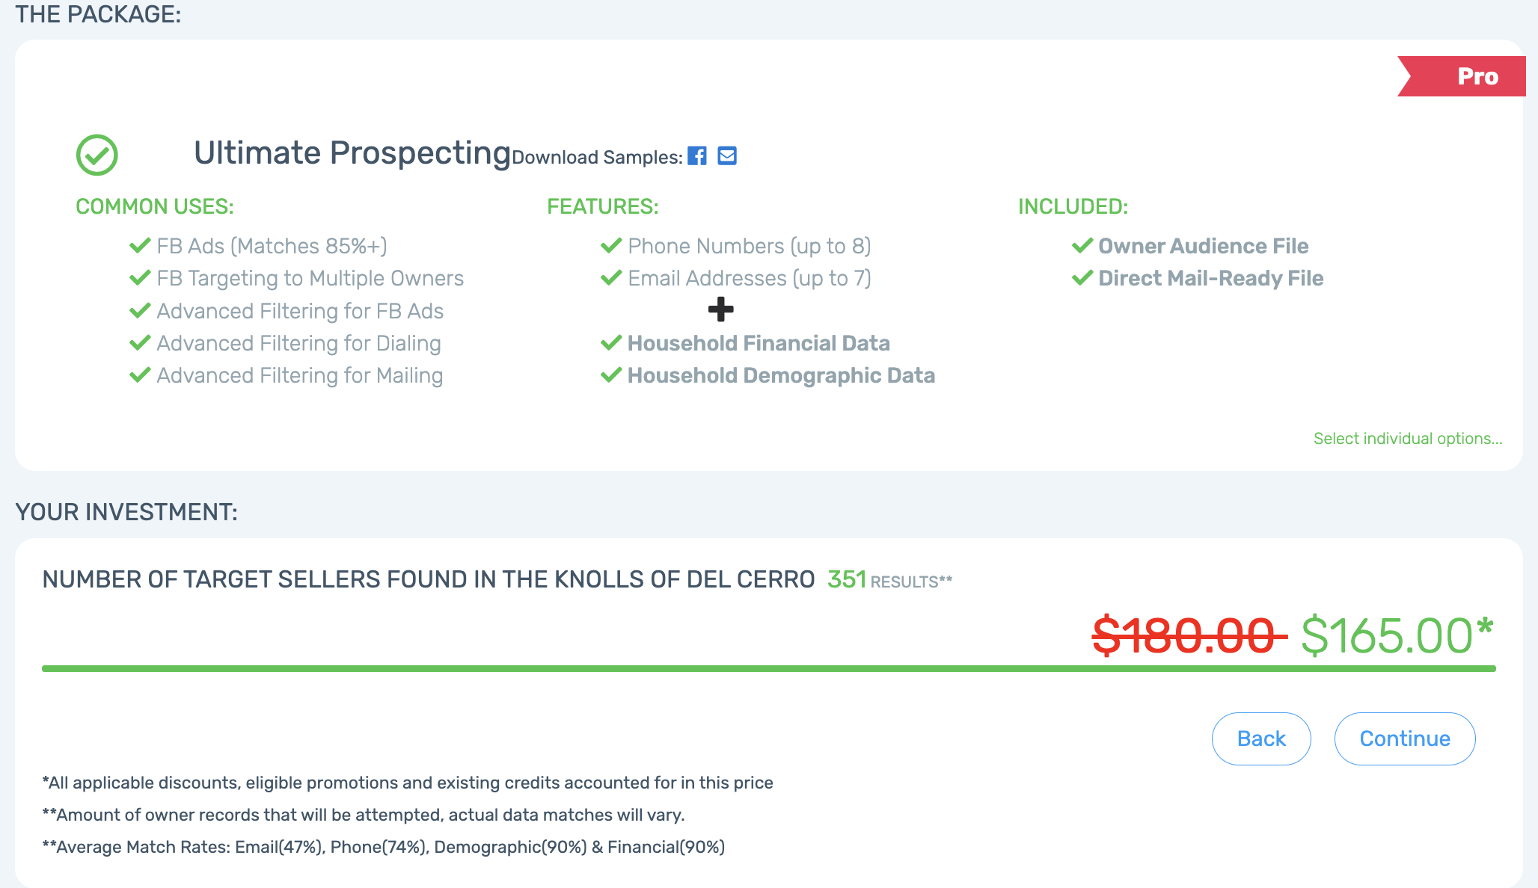

GeoSocial Audience Summary:
Del Cerro | Filtered Area
Targeted SFR Homes: 1318

Filters: Est Owners: 2142 (GeoSocial Audience)
- 4+ Bedroom Optimization: $1050
- 4+ Years in home

92119 | Filtered Zip Code
Post Filter SFR Homes: 3159

Filters: Est Owners: 5051 (GeoSocial Audience)
- 4+ Bedroom Optimization: $2475
- 4+ Years in home

The Knolls of Del Cerro
SFR Homes: 226

Filters: Est Owners: 351 (GeoSocial Audience)
- None Optimization: $165

Total Number of Homes: 4703

Total Audience Size: 7,544 Owners

Total Optimization: $3690

